1.0 INTRODUCTION
This report presents a comprehensive overview of marine incidents recorded during the year 2025 within the jurisdiction of Uganda police force marine unit. The report aims to provide an evidence-based account of incident trends, patterns and spatial distribution to inform crime prevention strategies and enhance public safety.
The report is based on crime data collected through routine reporting mechanisms from various marine police detachments. It covers a range of incidents including drowning, robberies, wild life attacks, and other related incidents. The analysis focuses on key variables such as nature of incident, place of occurrence, time of occurrences, Date of occurrence, Date of reporting, water body, zone/ Detachment where the incident occurred, activity before the incident occurred, number of fatalities, primary cause of the incident, number of persons rescued, number of body retrievals, property lost, property recovered e.t.c.
The unit operates across the country with 9(nine) zones, each comprising specific detachments as shown in table below.
S/N | ZONE | DETACHMENTS | Water Body
1. | VICTORIA NORTHEAST | Buvuma, Namugombe, Samba, Liibu | Lake Victoria
2. | VICTORIA EAST | Jinja, Bwondha | Lake Victoria
3. | VICTORIA SOUTH | Kalangala, Kasensero, Nkose | Lake Victoria
4. | RWENZORI | Kasese, Wamala, Bunyonyi | Lake Edward, Lake George, Lake Wamala, Lake Bunyonyi
5. | KYOGA | Bukungu, Zengebe, Kawongo, Kagwara | Lake Kyoga
6. | VICTORIA SOUTHEAST | Lolwe, Sigulu, Majanji, Lugala, Hama, Mijingo | Lake Victoria
7. | VICTORIA NORTH | Ggaba, Lugumba, Katosi | Lake Victoria
8. | VICTORIA SOUTHWEST | Entebbe, Kasenyi | Lake Victoria
9. | ALBERTINE | Panyimur, Butiaba, Sebagoro | Lake Albert

Lake Victoria is divided into six operational zones due to the high level of human activity and the frequency of reported incidents on the lake. This zonal arrangement is intended to enhance coordination, improve response times, and ensure effective management of operations across the lake.
By highlighting emerging trends and areas of concern, the report supports operational planning and informed decision-making by relevant stakeholders.

2.0 INCIDENT SUMMARY
The number of reported cases decreased by 32.6% in 2025, declining from 190 cases in 2024 to 128 cases in 2025. The incidents were documented through routine reporting systems from various detachments within the jurisdiction and represent a range of incidents handled during the reporting period.
The incidents comprised various categories, predominantly drowning incidents (81), followed by robberies (13), aggravated robberies (8), aggravated robberies and murder (4), murder cases (4), fatal boat accidents (2), abduction (1), attempted murder (2), wild life attacks resulting in loss of life (2) and other related incidents, as illustrated in figure 1.
Incidents were reported in all months of the year. Monthly figures show January (4 cases), February (10), March (9), April (16), May (13), June (6), July (13), August (14), September (8), October (17), November (11), and December (7). The monthly distribution of reported incidents is presented in Figure 2.
Furthermore, incidents recorded across major water bodies, with lake Victoria accounting for 82 cases, lake Kyoga 17 cases, lake Albert 9 cases, River Nile 5 cases, River Mayanja 3 cases, lake Edward 3 cases, lake Wamala 1case, and others as shown in figure 5
Although the number of incidents recorded by the Marine Unit was lower compared to the previous year, the unit’s operational importance remains critical. The observed reduction is largely attributed to sustained preventive interventions, including routine patrols, community sensitization, and enforcement of safety measures on water bodies. Given the high-risk nature of marine environments and the potentially severe consequences of incidents, the Marine Unit continues to play a vital role in safeguarding public safety.

3.0 KEY FINDINGS
3.1 FREQUENCY DISTRIBUTION OF INCIDENTS
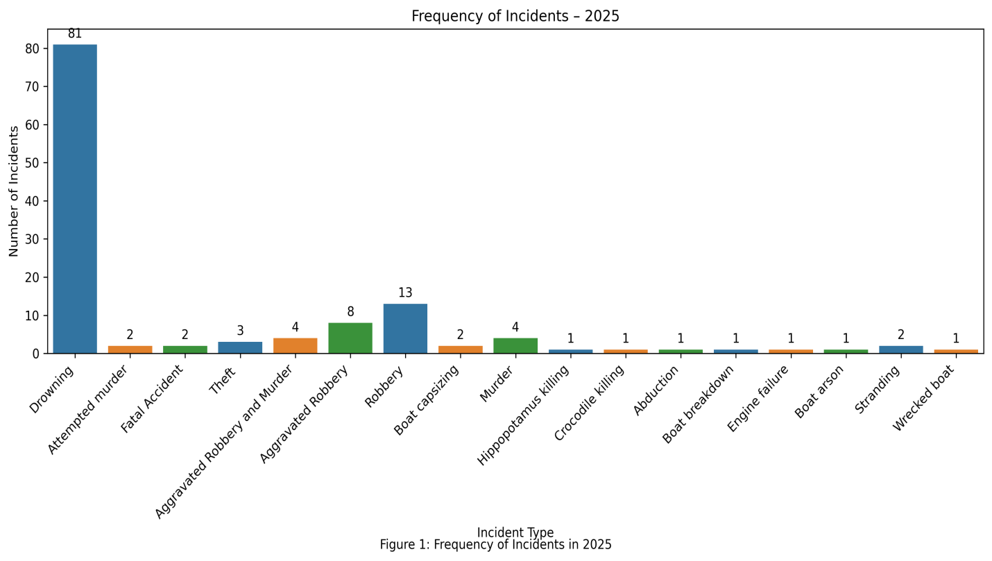
Drowning cases were most frequently reported incidents, accounting for 63.28% of the total incidents recorded during the year under review, followed by robberies, which accounted for 10.15%.
3.2 MONTHLY FREQUENCY DISTRIBUTION OF INCIDENTS

The monthly distribution of reported cases shows clear fluctuations throughout the year. Case numbers were lowest at the beginning of the year, with January recording only 4 cases, followed by a moderate increase in February (10 cases) and March (9 cases).
A notable rise was observed in April, where cases increased sharply to 16, indicating a period of heightened activity. Although there was a slight decline in May (13 cases), the number of cases remained relatively high compared to the first quarter.
Cases dropped significantly in June (6 cases), suggesting a temporary reduction in reported incidents. However, this decline was short-lived, as cases increased again in July (13 cases) and August (14 cases).
The number of cases fell in September (8 cases) before reaching the annual peak in October with 17 cases, making it the month with the highest reported incidents. Thereafter, cases declined steadily towards the end of the year, with November recording 11 cases and December 7 cases.

3.3 Distribution of Incidents by Water Boby
Incidents occurred across all major lakes as shown in figure 5:
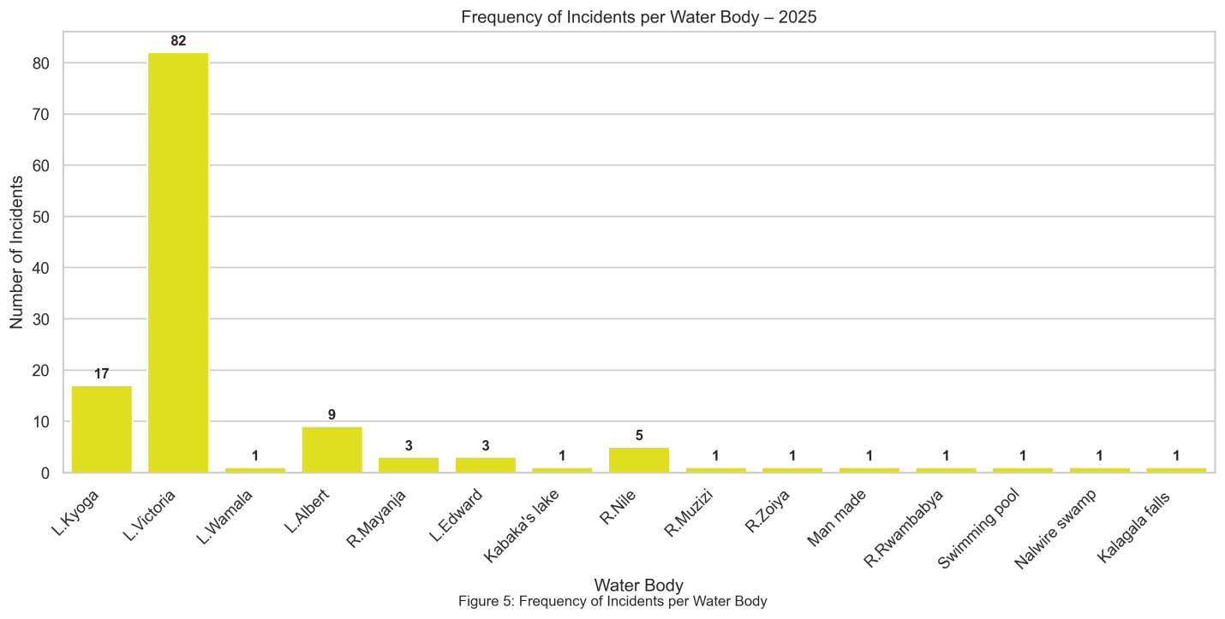
Lake Victoria registered the highest number of incidents, accounting for 64.1% of the total reported incidents followed by Lake Kyoga with 13.2%, indicating that these water bodies remain the most affected and require more heightened attention in terms of safety and enforcement interventions.

3.4.0 Findings on Dominant Incident Categories

3.4.1 Drowning
Drowning was the most frequently reported incident during the year as shown in Figure 1 above.
Primary Causes/ contributing factors included:
- boat capsizing due to bad weather
- Non- use of life jackets
- man overboard
- heavy tides
- inability to swim
- suicide
- alcohol influence
- overloading
- entry into deep waters by non-swimmers
- washing or bathing at the shore
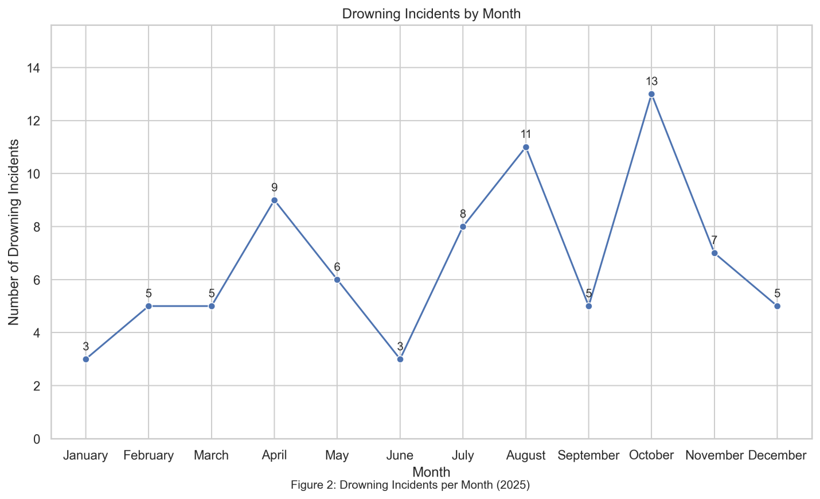
During the year under review, the month of October recorded the highest number of drowning incidents, indicating a peak in marine-related emergencies during this period. This was followed by the months of August, April and July, which also registered relatively high case numbers compared to the rest of the year. The trend may be attributed to increased fishing activities associated with seasonal variations. The pattern highlights the need for targeted enforcement and sensitization interventions in these peak periods to mitigate the occurrence of drowning incidents.
Drowning Incidents by Zone
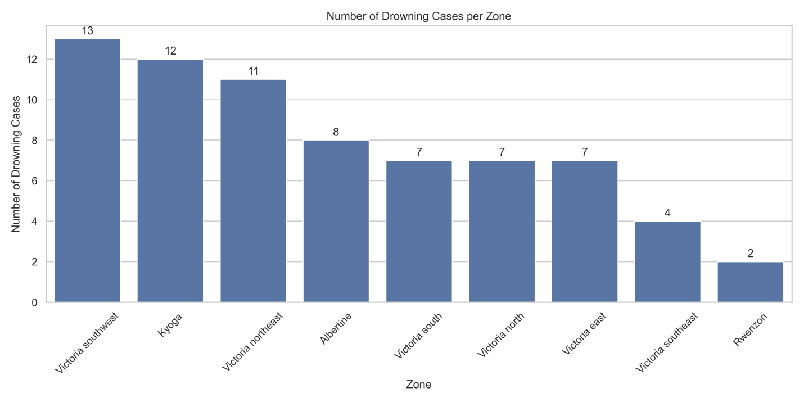
Lake Victoria southwest recorded the highest number incidents followed by lake Kyoga then lake Victoria northeast.

3.4.2 Robbery and Aggravated Robbery
A total of twenty-four (24) robbery incidents were recorded during the reporting period. The stolen items primarily included outboard engines and fishing nets, indicating a targeted pattern against fishermen. Analysis of incident locations shows that the majority of these robberies occurred within the Victoria Northeast Zone (refer to the figure below).
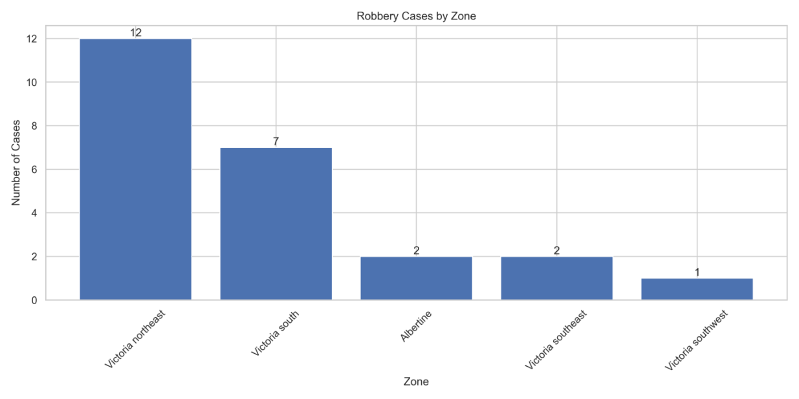

3.4.3 Murder and Attempted Murder

A total of 8 murder cases were reported and most cases took place in Kyoga Zone followed by Victoria northeast and Victoria south.
Murder incidents were reported in relation to:
- outright criminality
- disputes among fishermen
- piracy-style attacks on water
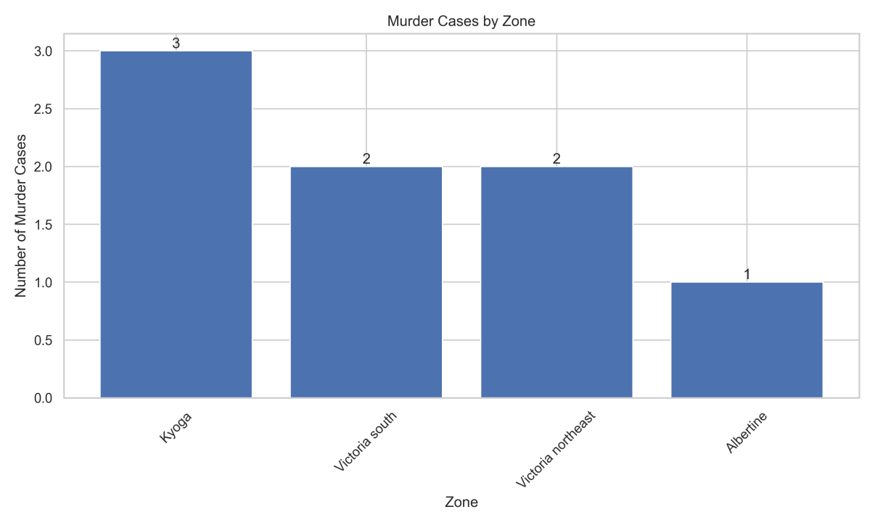

3.4.4 Wildlife-Related Incidents

Two (2) fatal wildlife-related incidents were reported during the period under review, comprising one (1) hippopotamus attack and one (1) crocodile attack.

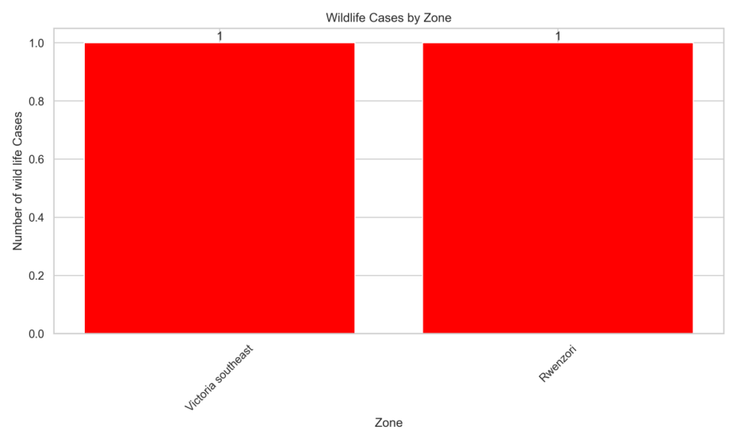
4.0 DISCUSSION
The findings indicate that drowning incidents constituted the majority of reported cases, accounting for 64.29% of all incidents recorded during the year under review. The dominance suggests that water safety remains a critical operational and public safety concern within the areas covered by the report. The high proportion of drowning cases highlights the continued vulnerability of water users, particularly in environments where safety measures may be inadequate or inconsistently observed.
The spatial distribution of incidents further shows that Lake Victoria recorded the highest number of cases, followed by Lake Kyoga and Lake Albert. This pattern may be attributed to the higher volume of water transport, fishing activities, and population density around Lake Victoria compared to other water bodies. Increased human activity on this lake likely elevates exposure to water related risks, thereby contributing to the higher number of reported incidents.
In addition, non- use of life jackets emerged as the common safety issue among individuals involved in water related incidents. Failure to wear life jackets significantly increases the risk of fatal outcomes, particularly during accidents or unexpected water emergencies. The persistence of this safety violation points to gaps in compliance, amidst increase in awareness and enforcement. Addressing this issue is essential in reducing the incidence and severity of drowning cases. Other contributing factors identified in the reported incidents included alcohol influence, overloading of vessels, suicide and man overboard occurrences, among others.
Although robbery cases constitute a smaller proportion of incidents (19.5%), their occurrence remains a notable concern, particularly in specific locations and time periods. Many of the affected fishermen operate in isolated areas, making them vulnerable to targeted attacks. As reported earlier, the robbed items primarily included outboard engines and fishing nets, indicating a pattern aimed at these communities. We recommend the adoption of technological interventions to curb the rising incidents of engine robbery. This would enhance traceability, improve recovery of stolen engines, and deter potential offenders.

5.0 Strategies Taken to Reduce Marine Incidents
The unit implemented a range of proactive strategies aimed at reducing marine incidents during the year. These included intensified routine patrols across major water bodies, increased community policing and sensitization on water safety, and strict enforcement of maritime laws and regulations. The unit strengthened collaboration with local leaders, beach management units, and other stakeholders to enforce reporting and early response to incidents. Emphasis was also placed on promoting the use of lifejackets, safe vessel loading practices, and discouraging alcohol consumption while on water. Additionally, capacity- building initiatives such as training of crews and first responders improved readiness and response time, contributing significantly to the reduction and effective management of marine incidents.

5.1 Marine Safety and Rescue Operations
The Marine Unit undertook:
- rescue of survivors
- recovery of bodies
- evacuation of stranded passengers
- towing of distressed vessels
- public sensitization on life jacket use
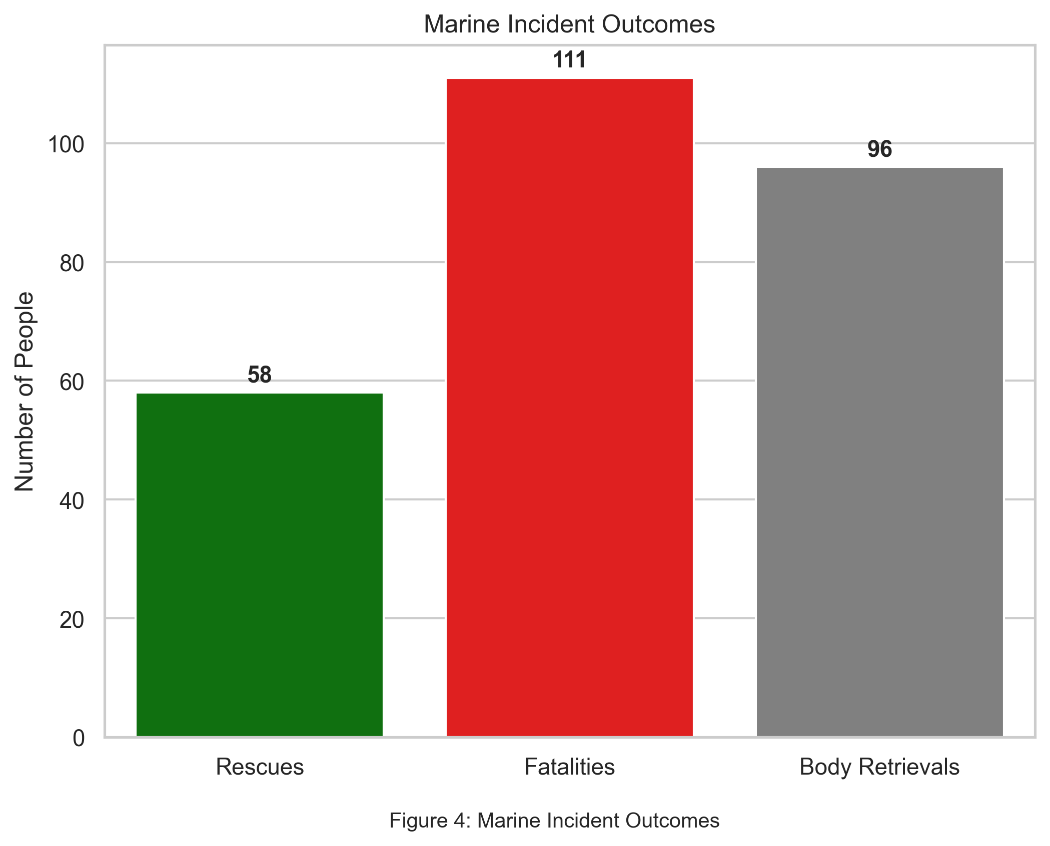
The Marine police also prioritized rapid response to emergencies, which contributed to the significant number of rescues recorded, as illustrated in figure 4.

5.1.1 Reported Stolen/Robbed and Recovered Outboard Engines
During the reporting period, a total of 27 outboard engines were reported stolen or robbed from fishermen across various water bodies. Of these, 9 engines were recovered, while 18 engines remained unrecovered at the time of reporting. Most engine-related robberies were recorded on Lake Victoria, followed by Lake Albert.

5.2 Community Engagements
During the reporting period, the Marine Unit successfully held over 90 community policing forums including radio/TV Shows aimed at sensitizing communities on marine safety, drowning prevention, and crime reporting.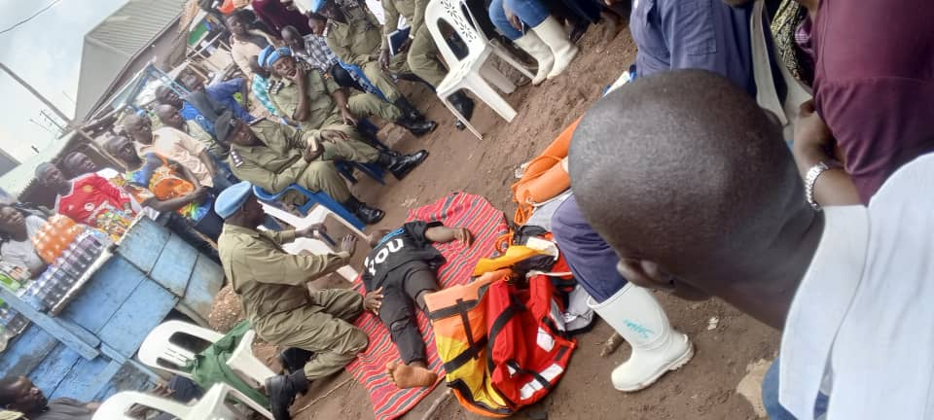
1: An officer demonstrated the provision of first aid to an unconscious person during a community policing engagement in Katosi, emphasizing emergency response skills and public safety awareness

5.3 Opening of Bukasa Detach
The commissioning of the Bukasa Detach(presided over by the commandant marine CP/Hajji Kirungi Sulaiman) marked a major milestone in expanding marine policing presence and accessibility. The detachment improves command coverage in the Bukasa area, enhances response time to incidents, and strengthens community engagement along the lakeshore. The facility also serves as a forward operating base for patrols and emergency operations within the surrounding waters.
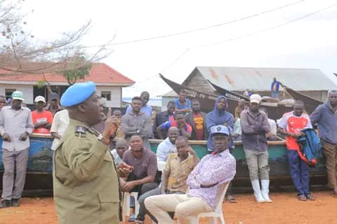
pic 1: The Commandant of the Marine unit, CP Hajj Kirungi Sulaiman, addressed the residents of Bukasa during the official opening of the Bukasa Detachment
5.4 Capacity Building of Marine Personnel
A number of trainings were carried out to build capacity of the officers in various areas.

5.4.1 Types of Training Conducted
a) Induction/Orientation Training
New officers were oriented on organizational structure, roles, code of conduct, and standard operating procedures.
b) Refresher Training
serving officers received refresher training to update skills, reinforce procedures, and address noted performance gaps.
c) Specialized/Technical Training
specialized training was conducted in areas such as:
- Diving
- Navigation
d) Physical Fitness and Drills
Physical training and parade drills were carried out to improve endurance, discipline, and readiness.
e) OUTREACH Training programs
These targeted community members working on water bodies; they trained in life saving and rescue drills.
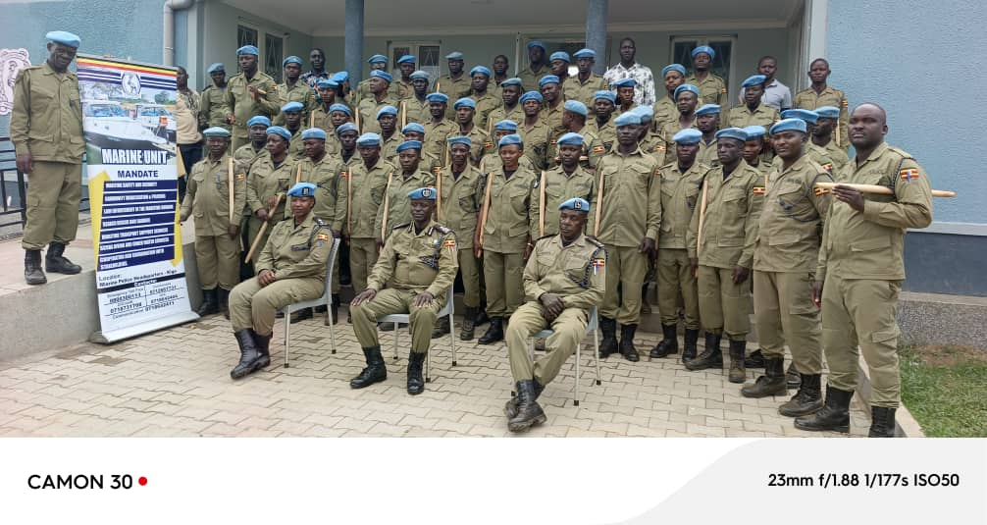
pic 2: The pass out ceremony for newly promoted corporals was conducted to officially confirm their new ranks and responsibilities

⚓ Prepared by:
ASP KAGIMU MOSES
Data Officer – Uganda Marine Police

